This outline and pseudo code is to specify the feature added. I will refer to this feature as the South Carolina Jobs Tiered Jobs Tax Credit (or SCJTJTC for short).

Descriptive usage:

When user selects “compare” on polygon in state of “South Carolina”,

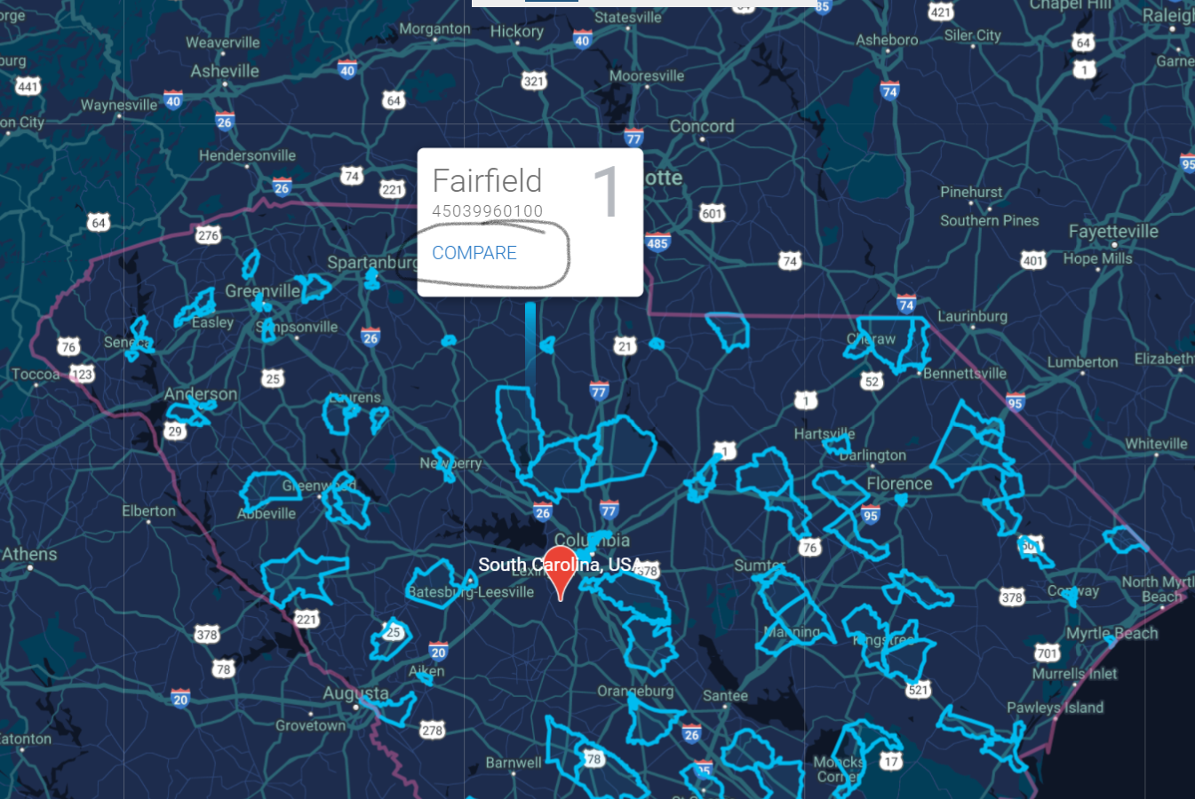

The last line (field) in the pop up should be “Job Tax Credit Available”, with value = “$55,589.83”. (placed in the red horizontal lines below)

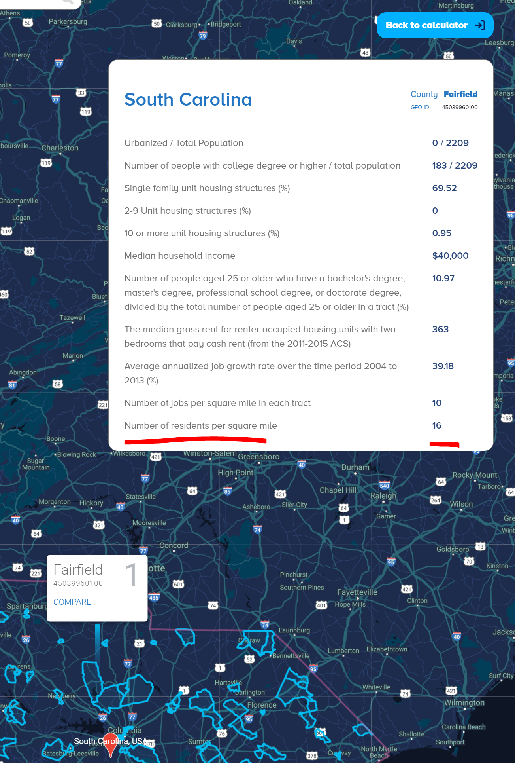

Since this number will be personalized for the user, if a user is logged in (see below for details), it will display their personalized value, rather than the default “$55,589.83”. Since this value is determined by the computation below, it must be dynamically calculated for depending on the user inputs and the polygon selected within the state of South Carolina. Therefore, each input to the prompts below must be saved to a user’s profile.

For instance, if a user has logged in (part of this feature) and a profile saved by the user using their inputted name this Jobs Tax Credit program feature, we autocompute the value here with calc below and display it. The “value” displayed with be an href to the prompts below in order to personalize the number.

The mouseover on “Jobs Tax Credit Available” (the left red line in the above snapshot) should say the following: “The South Carolina Tiered Jobs Tax Credit is a valuable financial incentive that rewards new and expanding companies for creating jobs in South Carolina. “

The mouseover on the value (i.e “55,589.83” or whatever personalized value is displayed) should say the following: “Based on 5-year employment. Personalize your tax credit”.

In order to personalized the value, we will need to prompt the user with a series of questions in the below order and manner.

Some notes to keep in mind throughout: every input must be saved (so we can do the auto computing / personalizing at the very beginning). If the user is not logged in, when a personalized value is computed, the user will be given an option to save their information by creating an account (email address and password).

Pseudo Code:

Global variables:

Numberofyears = 5

5_Year_Treasury = .0085

Inputs (displayed as white pop up like the picture above)

Y/N Prompt: Do you plan on hiring more than 1 person a year?

If no -> “You need to hire more than 1 person per year to receive this tax credit.”

Buttons to “restart” or “quit” at the bottom all pop ups. “Restart” goes back to the first question. “Quit” closes the pop up and return the user to the map as if they were before they clicked to personalize their score.

If yes - >

then ->

Select sector from following column: “South Carolina Tax Credit Sectors” Table, Field “Sector”.

|  |
| --- |
| Manufacturing |
| Processing |
| Agricultural Packaging |
| Warehousing and Distribution |
| Research and Development |
| Agribusiness operations |
| Technology |
| Corporate Office Facility * non sector specific (mouseover this option with the following text “Must house the ‘majority of headquarter functions’”  [North American Industry Classification System Manual Section Table] Subsector 621  [North American Industry Classification System Manual Section Table] Subsector 622  [North American Industry Classification System Manual Section Table Subsector] 623  [North American Industry Classification System Manual Section Table Subsector] 488190  Text Box “Other” (“Enter Value”) |
|  |

)

If (

|  |
| --- |
| Manufacturing |
| Processing |
| Agricultural Packaging |
| Warehousing and Distribution |
| Research and Development |
| Agribusiness operations |
| Technology |

Corporate Office Facility)

Then “Select the number of jobs created per year” Dropdown (numbers 10 – 100,000)

[run the following calculation and display value as the personalized value] - >

Jobs_selected*numberofyears*tier_value_per_employee (lookup from table South Carolina Jobs Tax Credit Tiers based on tier of polygon selected)/((1+5_Year_Treasury)^numberofyears)

If (

[North American Industry Classification System Manual Section Table Subsector 621]

[North American Industry Classification System Manual Section Table Subsector 622]

[North American Industry Classification System Manual Section Table Subsector 623]

[North American Industry Classification System Manual Section Table Subsector 488190]

If(polygon job tax credit value tier = 4), then

Jobs_selected*numberofyears*tier_value_per_employee (lookup from table South Carolina Jobs Tax Credit Tiers based on tier of polygon selected)/((1+5_Year_Treasury)^numberofyears)

If(polygon job tax credit value is tier 1 or 2 or 3), then

If [jobs created dropdown] >= 175

Then [run calc formula and display value) ->

Jobs_selected*numberofyears*tier_value_per_employee (lookup from table South Carolina Jobs Tax Credit Tiers based on tier of polygon selected)/((1+5_Year_Treasury)^numberofyears)

If [jobs created dropdown] >= 150 and <175, then

Y/N box prompt (“Are you willing to place these jobs in a currently vacant building?”

If yes then,

[run the following calculation and display value as the personalized value) - >

Jobs_selected*numberofyears*tier_value_per_employee (lookup from table South Carolina Jobs Tax Credit Tiers based on tier of polygon selected)/((1+5_Year_Treasury)^numberofyears)

If no then,

[run the following calculation and display value as the personalized value) ->

Jobs_selected*numberofyears*tier_value_per_employee (lookup from table South Carolina Jobs Tax Credit Tiers based on tier of polygon selected)/((1+5_Year_Treasury)^numberofyears).

Accompanying text must say: “Each job must pay at least [min(county table lookup per capita income, state table lookup per capital income)*1.5 per year.

If [jobs created dropdown] >= 100 and <150,

Then [run the following calculation and display value as the personalized value ->

Jobs_selected*numberofyears*tier_value_per_employee (lookup from table South Carolina Jobs Tax Credit Tiers based on tier of polygon selected)/((1+5_Year_Treasury)^numberofyears).

Accompanying text must say: “Each job must pay at least [min(county table lookup per capita income, state table lookup per capital income)*1.5 per year.

If [jobs created dropdown] >= 50 and <100,

Jobs_selected*numberofyears*tier_value_per_employee (lookup from table South Carolina Jobs Tax Credit Tiers based on tier of polygon selected)/((1+5_Year_Treasury)^numberofyears).

Accompanying text must say: “Each job must pay at least [min(county table lookup per capita income, state table lookup per capital income)*2 per year.

If [jobs created dropdown] >= 25 and <50,

Jobs_selected*numberofyears*tier_value_per_employee (lookup from table South Carolina Jobs Tax Credit Tiers based on tier of polygon selected)/((1+5_Year_Treasury)^numberofyears).

Accompanying text must say: “Each job must pay at least [min(county table lookup per capita income, state table lookup per capital income)*2.5 per year.

If [jobs created dropdown] >= 2 and <25,

Then “Select the number of jobs your company has worldwide”

Dropdown (numbers 2 – 100,000)

If dropdownnumber < 99

[run calc formula and display value) - >

Jobs_selected*numberofyears*tier_value_per_employee (lookup from table South Carolina Jobs Tax Credit Tiers based on tier of polygon selected)/((1+5_Year_Treasury)^numberofyears)

*Mouseover value “This credit requires jobs that pay (insert table look county hourly wage rate average -> look up county name in metrolist_to_msa table to get MSA value, then using MSA value look up h_mean value where occ_title = All Occupations *1.2), 120% or more of the county’s average hourly wage rate. For hour wages less than (insert same value), credits from $750 to $12,500 may be available for qualifying companies”.

Else Prompt(“You are not considered a small business within this program. You will need to create more than 25 jobs at a minimum to qualify for tax credits.”

When a personalized number is computed we will run this method:

-> Prompt text box “enter your email address to avoid reentering your data”.

prompt to create password with saved email address:

After the end of each “You are not eligible for this job tax credit”, we will run this method:

“Please enter your email address if you would like to be notified when you are eligible for changes in this program or others that fit your saved profile”

If(Text Box “Other” (“Enter Value”))

Then -> “This job tax credit does not yet include your sector. Please enter your email address if you would like to be notified when you are eligible”. Have text box to save email address and save button.

If (user clicks save)

Then -> prompt to create password with saved email address.

If(saved email address and profile is created)

Then -> prompt (“Save Scenario” Underneath a check box with the line: “Update me when the state creates credit for which this profile applies to your email address, text box).